EXPERIMENT 7

Aim: To develop a dashboard prototype displaying the performance of a cellular system using Figma.
Procedure:
• Open Figma and create a dashboard frame.
• Add the title “Cellular System Performance Dashboard.”
• Create cards for signal strength, network speed, call success rate, and network coverage.
• Add simple charts and progress bars to display performance.
• Use different colors to highlight the performance values.
• Arrange all elements neatly.
OUTPUT: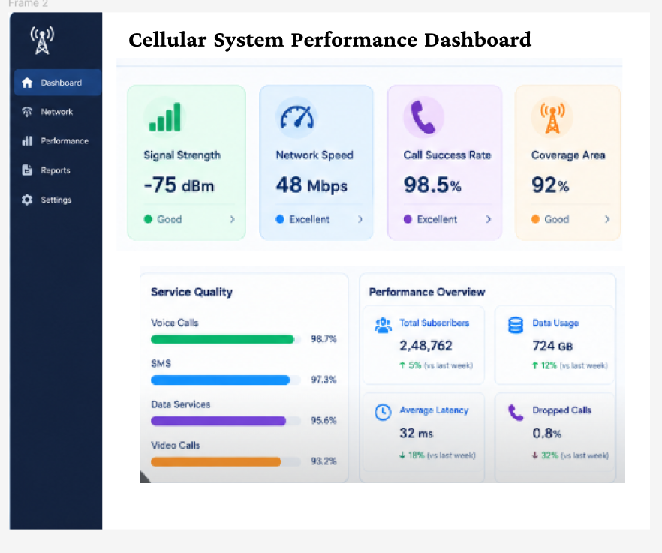

FIGMALINK:
https://www.figma.com/design/ED1qcVpNfWi2Zuft4amJyZ/Untitled?node-id=52-3&t=uA2KDN40aNTshT4h-0
RESULT: A cellular system performance dashboard was designed successfully using Figma.

